U.S. Memo
Date: August 28, 2019
To: Express Employment Professionals
From: The Harris Poll
Subject: 2019 Survey of White Collar & Grey Collar Americans

The survey was conducted online within the United States by The Harris Poll on behalf of Express Employment Professionals between June 18 and July 8, 2019 among 1,011 U.S. white collar workers (defined as adults ages 18+ in the U.S. who are employed full-time, part-time, or self-employed and works in an office, cubicle, or other administrative setting) and 1,019 grey collar workers (defined as adults ages 18+ who are employed full-time, part-time, or self-employed and works in one of the following professions: airline pilot or flight attendant, agribusiness professional (e.g., farmer, land manager), certified/licensed salesperson (e.g., real estate broker, stockbroker, insurance broker), clergy (e.g., minister, rabbi, imam), child care (e.g., nanny, au pair), engineer (e.g., mechanical, electrical, avionics, civil), firefighter, funeral director/technician, food preparation and catering (e.g., chef, sous chef), high-technology technician (e.g., lab technician, helpdesk technician, IT professional, medical equipment repair, solar panel installer), non-physician healthcare professional (e.g., nurse, emergency medical services personnel, physician’s assistant), paralegal, police officer, protective services, military, security or civil defense, professional musician/artist, school administrator, teacher, educator, or other academic field worker, or typist/stenographer). Results also were compared to a study conducted by The Harris Poll between July 9 and 23, 2018 among 1,049 U.S. blue collar workers who are employed full-time, part-time, or self-employed; performs work that requires manual labor; and works in one of the following industries: construction, manufacturing, transportation & warehousing, automotive services, maintenance, agriculture/ forestry/ fishing/ hunting, or utilities.

Figures are weighted where necessary by age by gender, race/ethnicity, region, education, income, marital status, employment, household size, and propensity to be online to bring them into line with their actual proportions in the population.

All sample surveys and polls, whether or not they use probability sampling, are subject to multiple sources of error which are most often not possible to quantify or estimate, including sampling error, coverage error, error associated with nonresponse, error associated with question wording and response options, and post-survey weighting and adjustments. Therefore, The Harris Poll avoids the words “margin of error” as they are misleading. All that can be calculated are different possible sampling errors with different probabilities for pure, unweighted, random samples with 100% response rates. These are only theoretical because no published polls come close to this ideal.

Totals may not equal the sum of their individual components due to rounding.

College Degree Worth It, But Significant Minority Worried About College Debt

For workers with a high school degree or less, most look back and wish they had chosen to attend community college, 4-year college, or vocational school, especially grey collar workers (grey, 72%; blue, 55%; white, 52%). Grey collar workers with a high school degree or less also are the most likely to say they would have had more opportunities available if they had instead decided to go to college (grey, 79%; blue, 72%; white, 60%).

The vast majority of college-educated grey collar and white collar workers say that the education that they received is at least somewhat helpful to the job they currently have (grey, 91%; white, 85%), with more than 1 in 3 grey collar workers (35%) and approximately 1 in 4 college-educated white collar workers (24%) saying it was absolutely essential. In fact, most college graduates, especially grey collar, believe going to college was worth every penny (grey, 79%; white, 70%). At least 3 in 4 grey collar (79%) and white collar workers (75%) believe people who pursue specialized education will be more appealing job candidates, and about 7 in 10 (grey, 71%; white, 70%) believe specialized professional degrees/diplomas provide workers with the best “bang for their buck.”

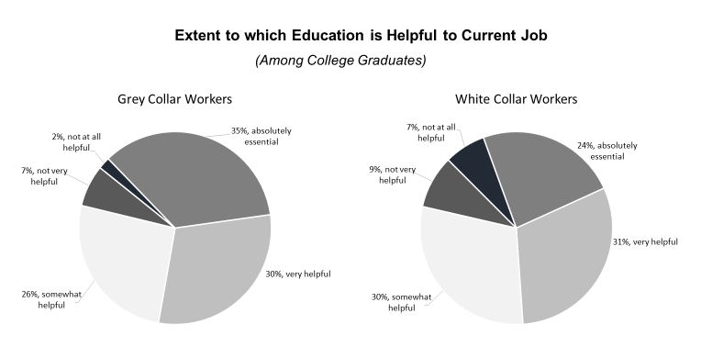
Still, some college-educated workers express regret and wish they had gone to community college, vocational school or straight into the workforce instead of getting a college degree (white, 31%; grey, 30%). Nearly 1 in 3 college-educated workers say they have too much student debt from going to college (grey, 32%; white, 31%) and cannot find a good job despite their college degree (white, 33%; grey, 28%). In fact, about 1 in 3 workers who attended vocational school or college (grey, 35%; white, 32%) report currently having student debt, with just under 1 in 5 (white, 18%; grey, 16%) saying they have at least $25K of student loan debt right now. Among those who are still shouldering student loan debt, they estimate it will take approximately 7-8 years on average to pay off.

Financial Status – Strong Majority Concerned about Retirement, Only Some Have at Least $5k Saved for Emergency

About half of all U.S. workers describe themselves as middle income class (grey, 52%; blue, 51%; white, 51%), though white collar and grey collar workers are more likely than blue collar workers to lean slightly toward upper or upper middle class (white, 34%; grey, 29%; blue, 11%). Still, the vast majority of workers (white, 88%; grey, 87%; blue, 84%) say they can make ends meet.

Most workers, more so white collar, say they’ve received a pay increase (white, 76%; grey, 70%; blue, 68%) as well as increased responsibilities (white, 58%; grey, 52%; blue, 45%) in the past year. White collar workers also are more likely to say they’ve received a promotion in the past year (white, 36%; blue, 35%; grey, 29%), and anticipate that they will receive a pay increase this year or next year (white, 68%; grey, 60%; blue, 55%).

Many workers (grey, 53%; blue, 51%; white, 49%) feel they are in a similar place financially to their neighbors, with nearly a third (white, 32%; grey, 29%; blue, 28%) saying they are better off than their neighbors. Many workers also say they are financially better off than their parents were at the same age (white, 50%; grey, 49%; blue, 40%), and believe their children will be financially better off than they currently are (though higher among blue collar workers: blue, 65%; white, 49%; grey, 47%).

Currently, many workers (blue, 62%; grey, 45%; white, 40%) have less than $5K saved in case of an emergency, though white collar workers are more likely to say they have a larger fund of at least $25K saved for an emergency (white, 33%; grey, 24%; blue, 11%). And, the majority of workers are worried about saving enough for their retirement, particularly blue collar workers (blue, 73%; white, 62%; grey, 59%). Only about half of U.S. workers are currently setting aside money for their retirement, with blue collar workers the least likely to say they are doing this (white, 58%; grey, 53%; blue, 42%).

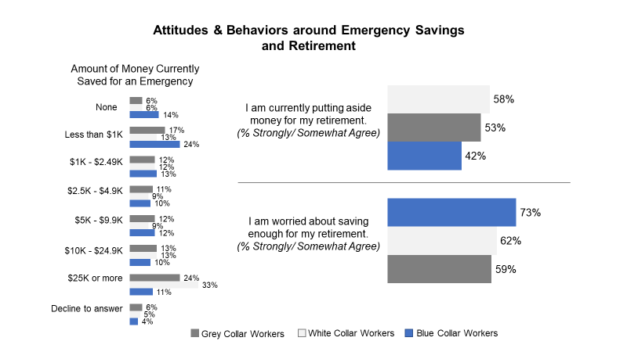

Personal Optimism & Job Satisfaction is High

More than 3 in 4 U.S. grey collar (76%) and white collar workers (76%) say they are satisfied with the lifestyle they have, compared to 67% of blue collar workers who say the same. In fact, slightly more than half of workers (white, 55%; blue, 55%; grey, 53%) say they are better off now than they were five years ago, and around 8 in 10 workers (grey, 84%; white, 79%; blue, 78%) are confident they will be able to reach their lifestyle goals. White collar (46%) and grey collar workers (43%) are more likely than blue collar workers (26%) to feel that life is not a struggle.

Looking ahead, approximately 8 in 10 U.S. workers are optimistic about their future (grey, 83%; white, 83%; blue, 80%), and most parents are hopeful for their children, believing their children will have an even better future than they will (blue, 88%; grey, 81%; white, 75%). An overwhelming majority of U.S. workers (grey, 88%; white, 86%; blue, 85%) say their life is moving in the right direction.

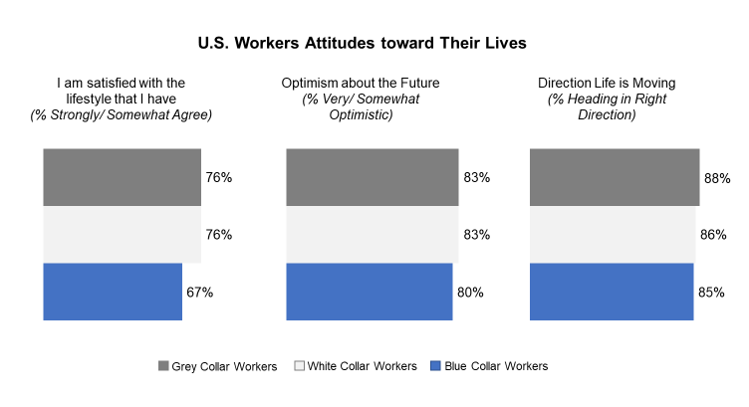
Nearly 2 in 5 grey collar (37%) and white collar workers (36%) say they are working in the job field they expected to have, higher than blue collar workers (28%). Although there doesn’t appear to be one singular path to how workers get into their respective fields, for grey collar (27%) and white collar workers (27%) it is most commonly because they are interested in the field, while blue collar workers are mainly drawn to their field because it is profitable (20%).

How Workers First Became Interested in Their Field of Work (Top 3)
White Collar Workers | Grey Collar Workers | Blue Collar Workers
- Interested in the field (27%) | - Interested in the field (27%) | - It’s profitable (20%)
- It’s enjoyable (12%) | - It’s enjoyable (13%) | - Other family members are in this line of work (15%)
- It’s profitable (12%) | - Job security (10%) | - It was the only job I could get (13%)

The majority of U.S. workers like their job (grey, 66%; white, 65%; blue, 59%). Most say they are at least somewhat satisfied with their job (grey, 88%; white, 86%; blue, 86%) and are proud of the work they do (blue, 91%; grey, 89%; white, 87%). Across the board, the majority of U.S. workers report their job provides a good living to financially support their family (white, 81%; blue, 80%; grey, 77%), and few worry they might lose it in the near future (white, 13%; blue, 13%; grey, 12%).

Most grey collar and white collar workers believe their boss cares about them personally (white, 80%; grey, 77%) and that their employer cares about its employees, though blue collar workers are less likely than grey or white collar workers to agree with this sentiment (white, 80%; grey, 77%; blue, 71%). Many full and part time U.S. workers say they have a great boss, though blue collar workers are the least likely to feel this way (white; 45%; grey, 40%; blue, 32%).

Many U.S. workers report their company treats them fairly, with white collar workers most likely to say this (white, 60%; grey, 51%; blue, 47%). Perhaps this is in part due to white collar workers being more likely than grey collar workers to say they can negotiate their salary or wage (white, 18%; grey, 12%). Notably, more than half of U.S. grey collar workers (53%) believe having a union would be helpful in their line of work, while white collar workers are far less likely (36%) to feel the same way.

Regardless of type of work, the top feature that U.S. workers value about their field is making a good living wage. Having flexible work hours also is a highly valued attribute for many workers.

Top 3 Attributes Workers Like About Their Job Field/Occupation
White Collar Workers | Grey Collar Workers | Blue Collar Workers
- Making a good living wage (53%) | - Making a good living wage (53%) | - Making a good living wage (53%)
- Flexible work hours (47%) | - Being able to help others/ Having a sense of purpose (48%) | - Being challenged by the type of work I do (40%)
- I like my boss (45%) | - Flexible work hours (42%) | - Flexible work hours (35%)

On the other hand, the top quality white collar and grey collar workers dislike about their job is having limited/no advancement opportunities (white, 30%; grey, 27%), followed by having little to no flexibility in work hours (grey, 19%; white, 15%). Though, for blue collar workers, the top attribute they dislike about their job is that it can be dangerous at times (39%), followed by limited/no advancement opportunities (28%).

Top 3 Attributes Workers Dislike About Their Job Field/Occupation
White Collar Workers | Grey Collar Workers | Blue Collar Workers
- Limited/no advancement opportunities (30%) | - Limited/no advancement opportunities (27%) | - It can be dangerous at times (39%)
- Little to no flexibility in work hours (15%) | - Little to no flexibility in work hours (19%) | - Limited/no advancement opportunities (28%)
- Type of work that I do is not challenging (15%) | - Not making a good living wage (19%) | - Little to no flexibility in work hours (23%)

However, if they had to do it all over again, about 3 in 4 grey collar (78%) and white collar workers (74%) say they would choose the same profession in which they are working now.

Outlook on Personal Job is Positive

About 3 in 4 U.S. workers (white, 75%; blue, 74%; grey, 72%) believe there is a good career path in their line of work. And, the majority believe more young men (grey, 70%; white, 66%; blue, 65%) and young women (grey, 72%; white, 71%; blue, 52%) should pursue careers in their field. Further, most would encourage a friend/family member (grey, 70%; white, 68%; blue, 64%) to pursue a career in their line of work, though are less apt to encourage a child to pursue their line of work (white, 64%; grey, 62%; blue, 51%). For those who would encourage a child to pursue the same career, the reasons for doing so are predominantly because it’s enjoyable (grey, 54%; white, 50%; blue, 47%) and profitable (blue, 58%; white, 52%; grey, 49%). Notably, grey collar workers are by far more likely than white collar workers to say they would encourage a child to explore a career in their field because there will be high demand for their profession in the future (grey, 45%; white, 31%).

The majority of U.S. blue collar (66%), grey collar (65%), and white collar (60%) workers say it is easy to find a job in their field right now. And, when thinking about the future, about a third of workers (white, 33%; grey, 31%) believe in 5 years there will be a greater number of jobs in the U.S. that are “grey collar”. Similarly, many workers believe there will be more jobs available in their field in the coming decade, particularly grey collar workers (grey, 40%; white, 27%).
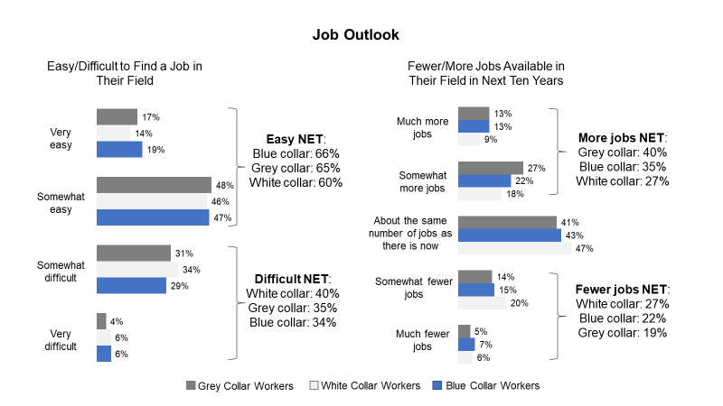

That said, many workers, especially grey collar say having their type of job is less respected now than it was 10 years ago (grey, 44%; white, 35%). Still, blue collar workers are more likely than grey collar and white collar workers to feel like society generally looks down on their line of work (blue, 58%; grey, 32%; white, 26%), and at times viewed as second-class citizens because of the type of work that they do (blue, 48%; grey, 33%; white, 27%). For those who would not encourage a child to pursue a career in the same industry, the main reason is lack of advancement opportunities (white, 39%; grey, 37%; blue, 37%), though blue collar and grey collar workers are more likely than white collar workers to also say long hours (blue, 39%; grey, 30%; white, 21%).

Nearly 2 in 5 grey collar (38%) and white collar workers (37%) – and nearly half of blue collar workers (48%) – say it is easy for their employer to find cheaper labor to do their job. Further, blue collar workers are nearly twice as likely as grey collar and white collar workers to say illegal immigrants make it harder for them to get a job in their field (blue, 37%; white, 20%; grey, 19%) and allow their employer to pay them less money to do their job (blue, 37%; white, 22%; grey, 21%).
U.S. workers view labels as accurate but also archaic and hurtful.

Although most U.S. white collar (83%) and grey collar workers (81%) view labels such as “grey collar”, “white collar”, and “blue collar” as a good way to describe the work they do, they also view these labels as old-fashioned and not applicable anymore (grey, 62%; white, 56%). This became evident when grey collar and white collar workers were asked which definition/label (e.g., blue collar, white collar, grey collar) best describes the work they do. Although the majority of white collar workers (80%) describe their work as “white collar”, it is less clear cut for grey collar workers with 49% saying “white collar”, 25% selecting “grey collar”, 14% saying “blue collar”, and 11% “something else”. There are also interesting differences by age, with younger grey collar workers 18-34 the most likely to label the type of work they do as “grey collar” (18-34, 31%; 35-54, 24%; 55+, 19%) or “blue collar” (18-34, 25%; 35-54, 9%; 55+, 8%).

The majority of white collar (76%) and grey collar workers (73%) believe labeling a profession as “blue collar”, “white collar”, or “grey collar” is not offensive to them personally, but do believe the labeling hurts how people view a particular line of work (grey, 62%; white, 59%) as well as the people who perform that particular line of work (grey, 60%; white, 60%). More than 1 in 4 grey collar (31%) and white collar workers (27%) go further and say they would likely be in another profession if it weren’t for the assigned label (e.g., “blue collar”, “white collar”).

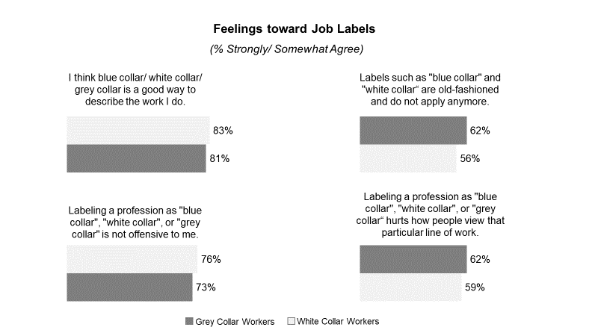

Political Scan –Healthcare, Affordability, Economy, Immigration Top List of Concerns; Workers Split on Whether President Doing a Good Job & Country Headed in Right Direction

While the majority of workers believe that their local community is heading in the right direction (grey, 72%; white, 72%; blue, 69%), much fewer say their state (white, 58%; blue, 58%; grey, 57%), or their country (blue, 51%; white, 47%; grey, 44%) is heading in the right direction.

U.S. grey collar and white collar workers' top concerns heading into the 2020 Presidential Election are: healthcare (grey, 54%; white, 50%), the economy (51% each), immigration (43% each), and the affordability of daily living (grey, 43%; white, 39%). At least 1 in 3 U.S. grey collar and white collar workers say they are very worried about each of these issues: affordability of daily living (grey, 38%; white, 35%), healthcare (grey, 40%; white, 36%), government corruption (grey, 42%; white, 38%), immigration (38% each), and the economy (grey, 34%; white, 31%).

U.S. white collar workers (59%) are more likely than grey collar (53%) and blue collar workers (51%) to describe the federal government as being pro-business, but all collar types appear torn as to which political party does a better job of helping Americans in their line of work, with workers fairly split on whether Democrats (grey, 38%; white, 37%; blue, 36%), Republicans (blue, 39%; white, 39%; grey, 35%), or neither (grey, 25%; blue, 24%; white, 22%) do a better job.

When it comes to President Trump, about half of U.S grey collar and white collar workers (grey, 49%; white, 48%) disapprove of the job that he is currently doing, compared to 40% of U.S. blue collar workers who disapprove; roughly four in ten workers approve of the job the President is doing (grey, 38% blue, 44%; white, 39%); and the remainder say they neither approve or disapprove (blue, 16%; white, 13%; grey, 13%). In addition, workers are split on whether President Trump has hurt (grey, 34%; white, 30%; blue, 28%), helped (blue, 36%; white, 33%; grey, 29%), or neither hurt nor helped their industry (blue, 37%; white, 37%; grey, 37%).

Worker Profile – Blue, white, and grey collar workers in the U.S. work fairly similar number of hours; pay structure and work location vary.

On average, U.S. workers have been employed for about two decades (white, 23 years; grey, 22 years; blue, 22 years), with the average worker saying they’ve been in their current job for about half that time (blue, 10 years; white, 10 years; grey, 9 years). The work week is fairly typical for employees, hovering around 40 hours (white, 41 hours/week; blue, 41 hours/week; grey, 39 hours/week).

The vast majority of white collar (92%) and grey collar workers (85%) work mostly indoors, compared to 42% of blue collar workers who say the same. When it comes to getting paid, pay structures vary by type of worker: two-thirds of white collar workers (66%) say they are salaried; half of grey collar workers (50%) are salaried, but nearly as many receive an hourly wage (48%); only 15% of blue collar workers characterize their pay as salaried, while the majority (80%) report being paid hourly.

Technology plays an important role for workers, more so for white collar and grey collar workers than blue collar. White collar and grey collar workers are 2-3x more likely than blue collar workers (white, 54%; grey, 43%; blue, 18%) to say using technology is a significant part of their job, and their job is in the technology sector (grey, 23%; white, 16%; blue, 7%).

